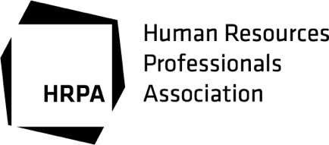

**Accessibility for Ontarians with Disabilities Act (AODA) Feedback Form**

Thank you for visiting HRPA. We value everyone and strive to meet their needs. We recognize that receiving feedback provides a valuable opportunity to learn and improve.

1. Date of Visit: Click here to enter a date. Time of Visit: :



2. Did we respond to your needs? Yes No  
  
If No, please explain:



3. Was our service provided to you in an accessible manner? Yes No  
  
If No, please explain:



4. Optional information - complete only if you wish to be contacted.

Preferred contact method:

Telephone: ext.



Email:



Mailing Address:



Name:



Address: City: Postal Code:



***Please complete the Customer Feedback Form and email the form to*** [***hr@hrpa.ca***](mailto:hr@hrpa.ca)***. If you have questions, call our HR Department 416-923-2324 x362 or email*** [***hr@hrpa.ca***](mailto:hr@hrpa.ca)***. All feedback is directed to HR and responses will follow within ten business days.***  
The Human Resources Professionals Association (HRPA) is committed to keeping the personal information of its members and customers accurate, confidential, secure and private. Our [Privacy Policy](https://www.hrpa.ca/Pages/Privacy-Policy.aspx) has been designed to inform employees, members, customers, and subcontractors of HRPA of our commitment and recognition to our obligation to meet the spirit and terms of the federal ***Personal Information Protection and Electronic Documents Act (PIPEDA).***